**DAILY ONLINE ACTIVITIES SUMMARY**

|  |  |  |  |  |  |  |  |  |
| --- | --- | --- | --- | --- | --- | --- | --- | --- |
| **Date:** | **15 June 2020** | | | | | **Name:** | **K. ISHA HEGDE** | |
| **Sem & Sec** | **4th sem, 2nd year** | | | | | **USN:** | **4al18cs031** | |
| **Online Test Summary** | | | | | | | | |
| **Subject** | | **--** | | | | | | |
| **Max. Marks** | | **---** | | **Score** | | | **---** | |
| **Certification Course Summary** | | | | | | | | |
| **Course** | **GETTING STARTED WITH MICROSOFT AZURE** | | | | | | | |
| **Certificate Provider** | | | **GreatLearning** | | **Duration** | | | **3 hours** |
| **Coding Challenges** | | | | | | | | |
| **Problem Statement:1 program** | | | | | | | | |
| **Status: Executed** | | | | | | | | |
| **Uploaded the report in Github** | | | | | **Yes** | | | |
| **If yes Repository name** | | | | | https://github.com/iishaii/locked-down_coding | | | |
| **Uploaded the report in slack** | | | | | **Yes** | | | |

**Certification Course Summary:** **Today I completed “GETTING STARTED WITH MICROSOFT AZURE’’ from great learning. It was live session and very informative. But there was no certificate provided.**





**QUIZ:**

I also attempted quiz on jun 6, and received a certificate today on 15th of jun.

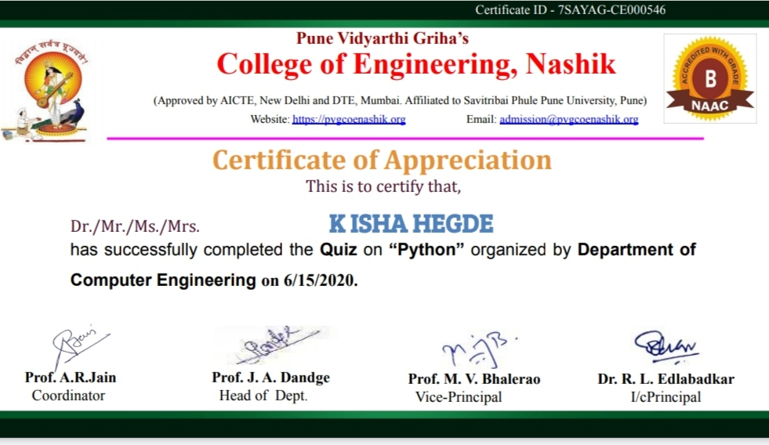

**Coding Challenges:**

Today I solved coding challenge,

1. **Write a Java Program to find if string is K-Palindrome or not**

A string is k palindrome if it can be transformed into a palindrome on removing at most k characters from it. Your task is to complete the function is_k_palin which takes two arguments a string str and a number N. Your function should return true if the string is k palindrome else it should return false.

**Input**:  
The first line of input is an integer T denoting the number of test cases. Then T test cases follow. Each test case contains a string str and an integer N separated by space.

**Output**:  
The output will be 1 if the string is k palindrome else 0.

**Example:**

**Input**: String - abcdecba, k = 1  
**Output**: Yes  
String can become palindrome by removing 1 character i.e. either d or e)

**Input**: String - abcdeca, K = 2  
**Output**: Yes  
Can become palindrome by removing  
2 characters b and e.

**Input**: String - acdcb, K = 1  
**Output**: No  
String cannot become palindrome by  
removing only one character.

**I have uploaded the code in github.**

